**PROJECT DESIGN PHASE – I**

SOLUTION ARCHITECTURE

|  |  |
| --- | --- |
| Date | 10 October 2022 |
| Team ID | PNT2022TMID51114 |
| Project Name | News Tracker Application |
| Maximum Marks | 4 Marks |

**Solution Architecture Diagram**: 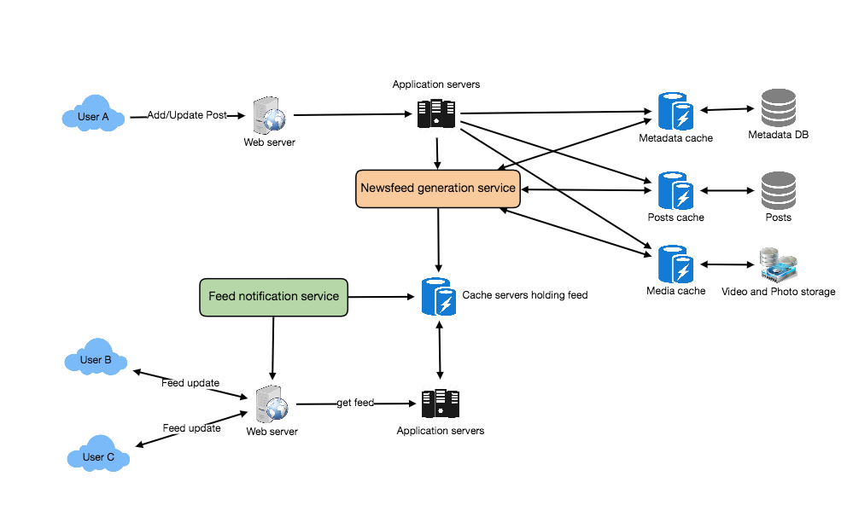

**Work Flow Diagram:**

